
North Bengal International University

Lab Report: 04

Exp Name : Longest common Subsequence(LCS)

Subject : Analysis of algorithm Sessional
Subject Code : CSE 0612-2212

Submitted By:
Name : Md. Tanvir Rahman Pranto
Dept : CSE(26)
Roll : 0712340012101005
Semester : 3rd Year, 5th semester.

Submitted To:
Name : Afsana Tasnim
Designation : (HOD)Lecturer
Dept : CSE
Date :

Task No: 01
Task Name: Longest common subsequence.
Introduction: Given two strings, L1 and L2, the task is to find the length of the Longest Common Subsequence. If there is no common subsequence, return 0. A subsequence is a string generated from the original string by deleting 0 or more characters, without changing the relative order of the remaining characters.
For example, subsequences of "ABC" are "", "A", "B", "C", "AB", "AC", "BC" and "ABC". In general, a string of length n has 2𝑛 subsequence.

Algorithm:
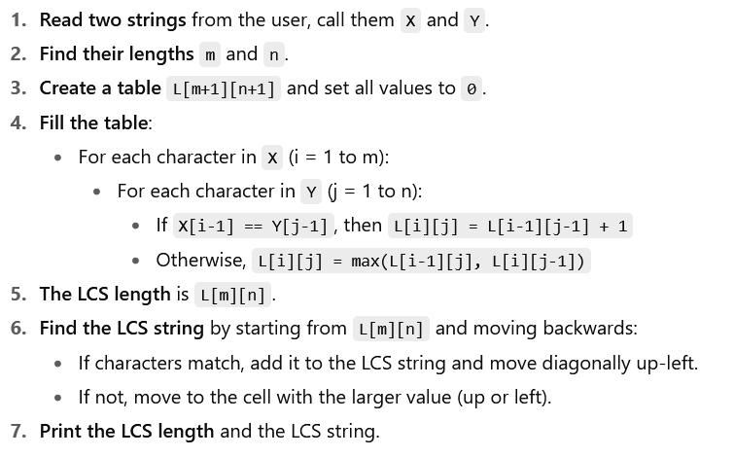

code:
#include <stdio.h>

#define MAX 100

int main() {
char X[MAX], Y[MAX], lcs[MAX];
int L[MAX][MAX];
int m = 0, n = 0;
int i, j;

printf("Enter first string: ");
scanf("%s", X);
printf("Enter second string: ");
scanf("%s", Y);

/* Find lengths of strings */
for (m = 0; X[m] != '\0'; m++);
for (n = 0; Y[n] != '\0'; n++);

/* Initialize table with 0 */
for (i = 0; i <= m; i++)
for (j = 0; j <= n; j++)
L[i][j] = 0;

/* Fill table */
for (i = 1; i <= m; i++) {
for (j = 1; j <= n; j++) {
if (X[i-1] == Y[j-1])
L[i][j] = L[i-1][j-1] + 1;
else
L[i][j] = (L[i-1][j] > L[i][j-1]) ? L[i-1][j] : L[i][j-1];
}
}

/* Reconstruct LCS */
int index = L[m][n];
lcs[index] = '\0';
i = m; j = n;
while (i > 0 && j > 0) {
if (X[i-1] == Y[j-1]) {
lcs[index-1] = X[i-1];
i--; j--; index--;
} else if (L[i-1][j] > L[i][j-1])
i--;
else
j--;
}

printf("Length of LCS: %d\n", L[m][n]);
printf("LCS: %s\n", lcs);

return 0;
}

output:
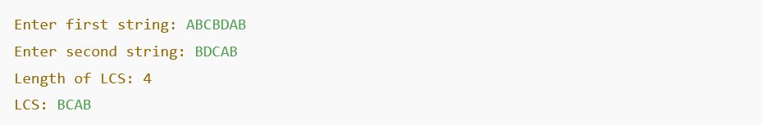
Conclusion: The LCS problem is a clear example of dynamic programming: build a table of subproblem results and use it to derive both the LCS length and the subsequence itself. The DP approach runs in O(m * n) time for strings of lengths m and n, and uses O(m * n) space for reconstruction. This lab demonstrated building the DP table and backtracking to reconstruct the sequence, and included a plain C implementation without user-defined functions.

